Plane Containment in Space

Definition
# Source: AI Source: Provided by: [Data Path: Persons Table -> ID Column: 1, Name_En Column: Motasem Essam] -> From: [ChatGPT] on [7/25/2026]
Plane Containment in Space occurs when an entire plane is contained within three-dimensional space.
If the plane is represented by $Π$and three-dimensional Euclidean space is represented by $R^{3}$, then:
$$\boxed{Π⊂R^{3}}$$
This means that every point of the plane is a point in three-dimensional space:
$$\boxed{P∈Π⇒P∈R^{3}}$$
A plane is therefore a two-dimensional geometric object embedded in three-dimensional space.
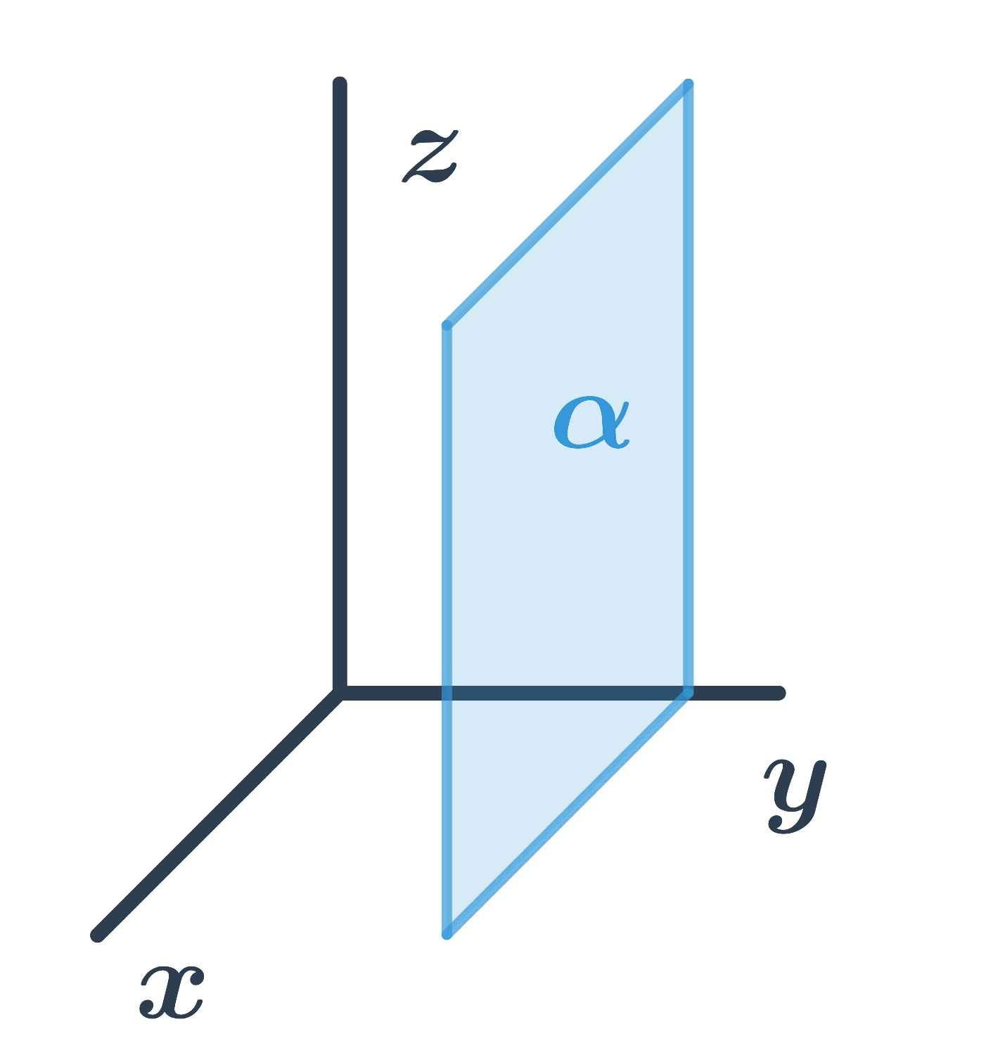
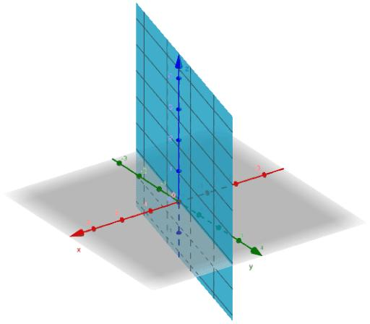
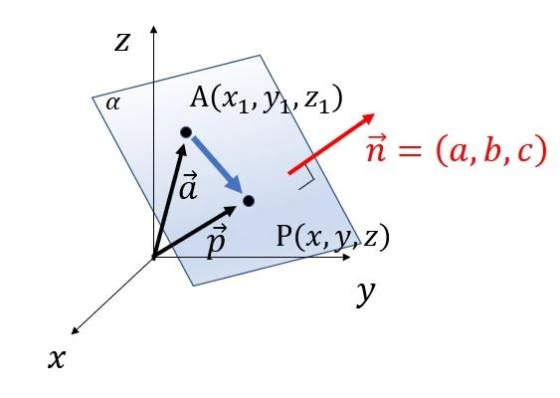
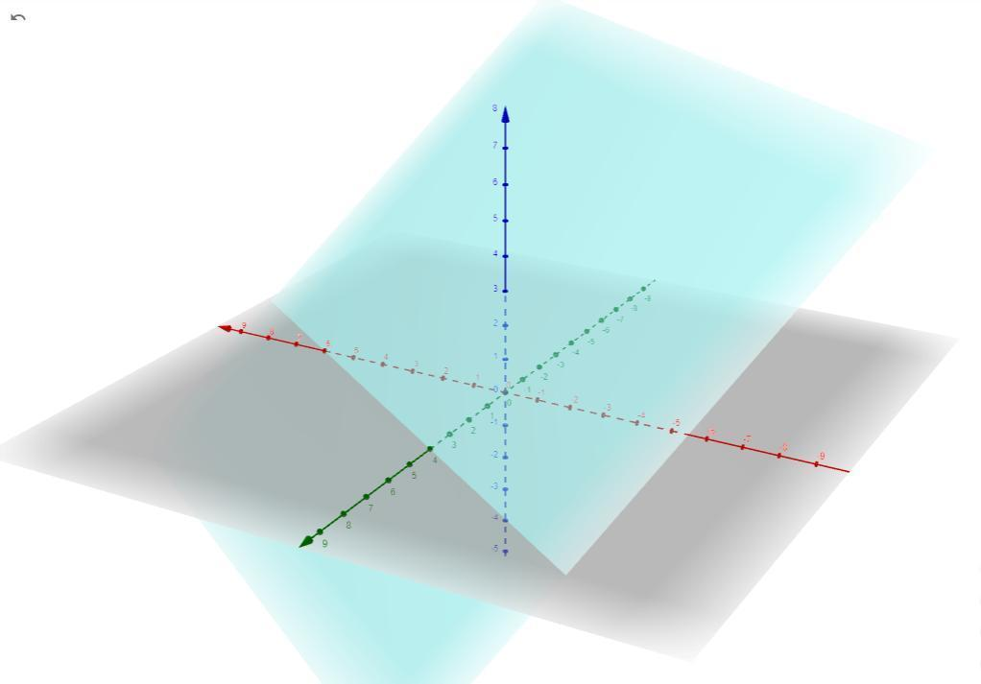
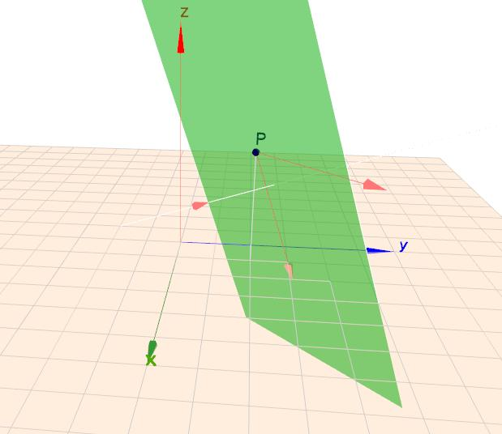

Purpose
# Source: AI Source: Provided by: [Data Path: Persons Table -> ID Column: 1, Name_En Column: Motasem Essam] -> From: [ChatGPT] on [7/25/2026]
Plane containment in space establishes the fundamental relationship between a plane and the three-dimensional space in which it exists.
It is important for understanding:
- Three-dimensional Euclidean geometry
- Solid geometry
- Coordinate geometry
- Vector geometry
- Spatial relationships
- Surfaces
- Solids
- 3D modeling
- CAD
- Computer graphics

Fundamental Concept
# Source: AI Source: Provided by: [Data Path: Persons Table -> ID Column: 1, Name_En Column: Motasem Essam] -> From: [ChatGPT] on [7/25/2026]
Three-dimensional space, commonly written as:
$$R^{3}$$
contains all points having three coordinates:
$$\left(x , y , z\right)$$
A plane is a two-dimensional subset of this space.
Therefore:
$$\boxed{Π⊂R^{3}}$$
Conceptually:
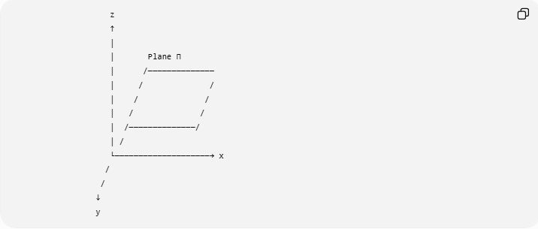
z
↑
│
│ Plane Π
│ /──────────────
│ / /
│ / /
│ / /
│ /──────────────/
│ /
└────────────────────→ x
/
/
↓
y
The plane extends infinitely in its own two dimensions, while the surrounding space extends in three dimensions.

Mathematical Representation
# Source: AI Source: Provided by: [Data Path: Persons Table -> ID Column: 1, Name_En Column: Motasem Essam] -> From: [ChatGPT] on [7/25/2026]
A plane in three-dimensional Cartesian space can be represented by:
$$\boxed{ax+by+cz=d}$$
where $a,b,c,d∈R$, and:
$$\left(a , b , c\right)≠\left(0 , 0 , 0\right)$$
Every point satisfying this equation belongs to the plane.
Thus:
$$Π=\left\{\left(x , y , z\right)∈R^{3}∣ax+by+cz=d\right\}$$
Consequently:
$$\boxed{Π⊂R^{3}}$$

Point-by-Point Interpretation
# Source: AI Source: Provided by: [Data Path: Persons Table -> ID Column: 1, Name_En Column: Motasem Essam] -> From: [ChatGPT] on [7/25/2026]
If:
$$P=\left(x , y , z\right)$$
belongs to the plane:
$$P∈Π$$
then, because the plane exists within $R^{3}$:
$$\boxed{P∈R^{3}}$$
Therefore:
$$\boxed{P∈Π⇒P∈R^{3}}$$
However, the reverse statement is not true:
$$P∈R^{3}⇏P∈Π$$
A point can exist in three-dimensional space without lying on a particular plane.

Fundamental Elements
# Source: AI Source: Provided by: [Data Path: Persons Table -> ID Column: 1, Name_En Column: Motasem Essam] -> From: [ChatGPT] on [7/25/2026]
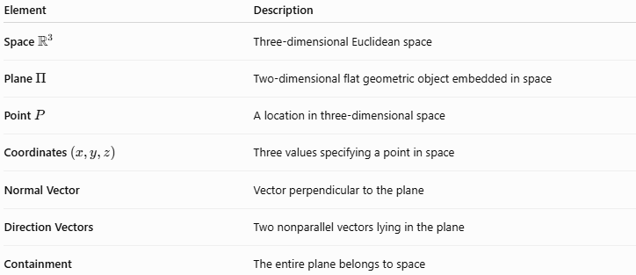
Element | Description
Space $R^{3}$ | Three-dimensional Euclidean space
Plane $Π$ | Two-dimensional flat geometric object embedded in space
Point $P$ | A location in three-dimensional space
Coordinates $\left(x , y , z\right)$ | Three values specifying a point in space
Normal Vector | Vector perpendicular to the plane
Direction Vectors | Two nonparallel vectors lying in the plane
Containment | The entire plane belongs to space

Dimension Relationship
# Source: AI Source: Provided by: [Data Path: Persons Table -> ID Column: 1, Name_En Column: Motasem Essam] -> From: [ChatGPT] on [7/25/2026]
One of the most important aspects of this containment is the difference in dimension.
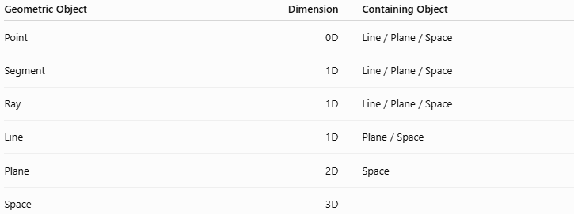
Geometric Object | Dimension | Containing Object
Point | 0D | Line / Plane / Space
Segment | 1D | Line / Plane / Space
Ray | 1D | Line / Plane / Space
Line | 1D | Plane / Space
Plane | 2D | Space
Space | 3D | —
Thus:
$$\boxed{\text{Plane }\left(2D\right)⊂\text{Space }\left(3D\right)}$$
This is a natural progression of geometric containment.

Parametric Representation
# Source: AI Source: Provided by: [Data Path: Persons Table -> ID Column: 1, Name_En Column: Motasem Essam] -> From: [ChatGPT] on [7/25/2026]
A plane can be represented parametrically as:
$$\boxed{r=r_{0}+su+tv}$$
where:
- $r_{0}$is a point on the plane;
- $u$and $v$are two nonparallel vectors lying in the plane;
- $s,t∈R$.
For example:
$$r_{0}=\left(1 , 2 , 3\right) \\ u=\left(1 , 0 , 2\right) \\ v=\left(0 , 1 , 1\right)$$
Then:
$$r=\left(1 , 2 , 3\right)+s\left(1 , 0 , 2\right)+t\left(0 , 1 , 1\right)$$
Every resulting point is a point in $R^{3}$.
Therefore:
$$\boxed{Π⊂R^{3}}$$

Example
# Source: AI Source: Provided by: [Data Path: Persons Table -> ID Column: 1, Name_En Column: Motasem Essam] -> From: [ChatGPT] on [7/25/2026]
Consider the plane:
$$Π:x+y+z=6$$
Its set representation is:
$$Π=\left\{\left(x , y , z\right)∈R^{3}∣x+y+z=6\right\}$$
Consider:
$$P=\left(1 , 2 , 3\right)$$
Since:
$$1+2+3=6$$
we have:
$$P∈Π$$
and therefore:
$$P∈R^{3}$$
Now consider:
$$Q=\left(1 , 2 , 5\right)$$
Although:
$$Q∈R^{3}$$
we have:
$$1+2+5=8≠6$$
so:
$$Q∉Π$$
Thus:
$$Q∈R^{3}$$
but:
$$Q∉Π$$
This illustrates that space contains the plane, but space contains many points that are not on that particular plane.

Plane as a Subset of Space
# Source: AI Source: Provided by: [Data Path: Persons Table -> ID Column: 1, Name_En Column: Motasem Essam] -> From: [ChatGPT] on [7/25/2026]
The relationship can be visualized as:
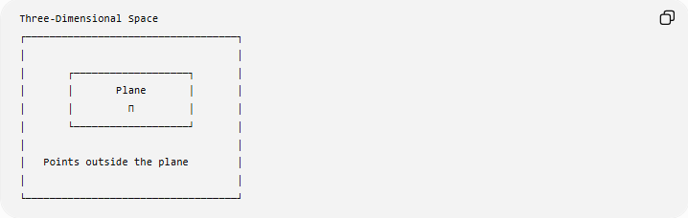
Three-Dimensional Space
┌───────────────────────────────────┐
│ │
│ ┌───────────────────┐ │
│ │ Plane │ │
│ │ Π │ │
│ └───────────────────┘ │
│ │
│ Points outside the plane │
│ │
└───────────────────────────────────┘
The plane is not a separate universe from space. It is a subset of the points of space.

Relationship with Points
# Source: AI Source: Provided by: [Data Path: Persons Table -> ID Column: 1, Name_En Column: Motasem Essam] -> From: [ChatGPT] on [7/25/2026]
A plane contains infinitely many points.
For example:
$$P_{1},P_{2},P_{3},…∈Π$$
and each of those points is also in space:
$$P_{i}∈R^{3}$$
Therefore:
$$\boxed{P_{i}∈Π⊂R^{3}}$$

Relationship with Lines
# Source: AI Source: Provided by: [Data Path: Persons Table -> ID Column: 1, Name_En Column: Motasem Essam] -> From: [ChatGPT] on [7/25/2026]
A line contained in a plane is also contained in space.
If:
$$l⊂Π$$
and:
$$Π⊂R^{3}$$
then:
$$\boxed{l⊂R^{3}}$$
Thus the containment chain becomes:
$$\boxed{l⊂Π⊂R^{3}}$$

Relationship with Segments
# Source: AI Source: Provided by: [Data Path: Persons Table -> ID Column: 1, Name_En Column: Motasem Essam] -> From: [ChatGPT] on [7/25/2026]
Similarly, if:
$$\overset{‾}{AB}⊂l$$
and:
$$l⊂Π$$
then:
$$Π⊂R^{3}$$
so:
$$\boxed{\overset{‾}{AB}⊂l⊂Π⊂R^{3}}$$
This demonstrates transitive containment.

Relationship with Rays
# Source: AI Source: Provided by: [Data Path: Persons Table -> ID Column: 1, Name_En Column: Motasem Essam] -> From: [ChatGPT] on [7/25/2026]
If:
$$\vec{AB}⊂l$$
and:
$$l⊂Π$$
then:
$$\boxed{\vec{AB}⊂Π}$$
and because:
$$Π⊂R^{3}$$
we also have:
$$\boxed{\vec{AB}⊂R^{3}}$$

Plane vs. Surface
# Source: AI Source: Provided by: [Data Path: Persons Table -> ID Column: 1, Name_En Column: Motasem Essam] -> From: [ChatGPT] on [7/25/2026]
A plane is a particular type of surface.
Therefore, if $S$represents the plane as a surface:
$$Π⊂S$$
and:
$$S⊂R^{3}$$
The important distinction is that a plane is flat, while a general surface may be curved.
Examples of surfaces in $R^{3}$include:
- Plane
- Sphere
- Cylinder
- Cone
- Paraboloid
- Torus
All of these are two-dimensional geometric objects embedded in three-dimensional space.

Plane vs. Solid
# Source: AI Source: Provided by: [Data Path: Persons Table -> ID Column: 1, Name_En Column: Motasem Essam] -> From: [ChatGPT] on [7/25/2026]
A plane is not a solid.
A plane is:
$$\boxed{2D}$$
while a solid occupies a three-dimensional volume:
$$\boxed{3D}$$
For example, a sphere's surface is a 2D subset of $R^{3}$, while a solid ball occupies a 3D region of $R^{3}$.
Thus:
$$\boxed{\text{Plane}⊂R^{3}}$$
but the plane itself has no volume.

Plane Containment vs. Plane–Solid Intersection
# Source: AI Source: Provided by: [Data Path: Persons Table -> ID Column: 1, Name_En Column: Motasem Essam] -> From: [ChatGPT] on [7/25/2026]
If a plane is used as a geometric reference and a solid occupies a region of space, the plane may:
- pass through the solid;
- touch the solid;
- remain outside the solid.
This is an intersection relationship, not plane containment in the solid.
A plane can be contained in space, but an entire infinite plane generally cannot be contained inside an ordinary finite solid.
Therefore, it is important to distinguish:
$$\boxed{Π⊂R^{3}}$$
from:
$$\boxed{Π∩V}$$
where $V$is a solid.

Plane Containment vs. Coincidence
# Source: AI Source: Provided by: [Data Path: Persons Table -> ID Column: 1, Name_En Column: Motasem Essam] -> From: [ChatGPT] on [7/25/2026]
A plane and three-dimensional space cannot be coincident.
Coincidence means equality of geometric sets.
But:
$$dim⁡\left(Π\right)=2$$
while:
$$dim⁡\left(R^{3}\right)=3$$
Therefore:
$$\boxed{Π⊊R^{3}}$$
rather than:
$$Π=R^{3}$$

Plane Containment and Boundary
# Source: AI Source: Provided by: [Data Path: Persons Table -> ID Column: 1, Name_En Column: Motasem Essam] -> From: [ChatGPT] on [7/25/2026]
A plane has no boundary in its own two-dimensional geometry.
It extends indefinitely in all directions within the plane.
However, it is still a subset of three-dimensional space.
Therefore, the plane does not form the "boundary" of all space.
Instead:
$$\boxed{Π\text{ is a 2D subset of 3D space}}$$

Coordinate Planes
# Source: AI Source: Provided by: [Data Path: Persons Table -> ID Column: 1, Name_En Column: Motasem Essam] -> From: [ChatGPT] on [7/25/2026]
The three standard coordinate planes are naturally contained in $R^{3}$.

$xy$-Plane
# Source: AI Source: Provided by: [Data Path: Persons Table -> ID Column: 1, Name_En Column: Motasem Essam] -> From: [ChatGPT] on [7/25/2026]
$$\boxed{z=0}$$
Therefore:
$$xy\text{-plane}⊂R^{3}$$

$xz$-Plane
# Source: AI Source: Provided by: [Data Path: Persons Table -> ID Column: 1, Name_En Column: Motasem Essam] -> From: [ChatGPT] on [7/25/2026]
$$\boxed{y=0}$$
Therefore:
$$xz\text{-plane}⊂R^{3}$$

$yz$-Plane
# Source: AI Source: Provided by: [Data Path: Persons Table -> ID Column: 1, Name_En Column: Motasem Essam] -> From: [ChatGPT] on [7/25/2026]
$$\boxed{x=0}$$
Therefore:
$$yz\text{-plane}⊂R^{3}$$
These planes intersect at the origin:
$$\boxed{\left(0 , 0 , 0\right)}$$

Important Properties
# Source: AI Source: Provided by: [Data Path: Persons Table -> ID Column: 1, Name_En Column: Motasem Essam] -> From: [ChatGPT] on [7/25/2026]
1. A plane is a subset of 3D space
$$\boxed{Π⊂R^{3}}$$
2. Every point on the plane belongs to space
$$\boxed{P∈Π⇒P∈R^{3}}$$
3. Not every point in space belongs to the plane
$$\boxed{P∈R^{3}⇏P∈Π}$$
4. The plane is two-dimensional
$$dim⁡\left(Π\right)=2$$
5. Space is three-dimensional
$$dim⁡\left(R^{3}\right)=3$$
6. A line contained in the plane is also contained in space
$$l⊂Π⇒l⊂R^{3}$$
7. A segment contained in the plane is also contained in space
$$\overset{‾}{AB}⊂Π⇒\overset{‾}{AB}⊂R^{3}$$
8. Containment is transitive
$$A⊂B, B⊂C⇒A⊂C$$

Containment Hierarchy
# Source: AI Source: Provided by: [Data Path: Persons Table -> ID Column: 1, Name_En Column: Motasem Essam] -> From: [ChatGPT] on [7/25/2026]
This topic completes an important progression in your containment taxonomy:
$$\boxed{\text{Point}⊂\text{Line}⊂\text{Plane}⊂\text{Space}}$$
For example:
$$\boxed{P∈l, l⊂Π, Π⊂R^{3}}$$
therefore:
$$\boxed{P∈R^{3}}$$
A more detailed hierarchy is:
$$\boxed{\overset{‾}{AB}⊂\vec{AB}⊂\overset{↔}{AB}⊂Π⊂R^{3}}$$

Real-World Applications
# Source: AI Source: Provided by: [Data Path: Persons Table -> ID Column: 1, Name_En Column: Motasem Essam] -> From: [ChatGPT] on [7/25/2026]
1. CAD
3D CAD systems represent planar faces as two-dimensional objects embedded in three-dimensional model space.
2. Engineering
Reference planes are used to define:
- construction geometry;
- cross-sections;
- measurement surfaces;
- assembly references.
3. Computer Graphics
A rendered 3D scene consists of objects positioned in three-dimensional space, with planar surfaces embedded within it.
4. Architecture
Floor plans and wall surfaces can be modeled as planar regions within 3D building space.
5. Robotics
A robot operating on a flat surface can be modeled using a plane contained in three-dimensional workspace.
6. Physics
Motion constrained to a flat surface can be modeled as motion within a plane in $R^{3}$.

Comparison with Related Concepts
# Source: AI Source: Provided by: [Data Path: Persons Table -> ID Column: 1, Name_En Column: Motasem Essam] -> From: [ChatGPT] on [7/25/2026]
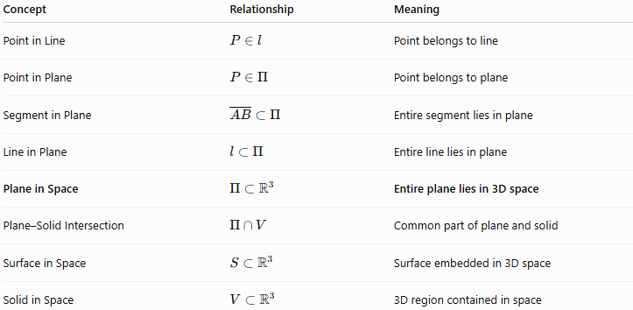
Concept | Relationship | Meaning
Point in Line | $$P∈l$$ | Point belongs to line
Point in Plane | $$P∈Π$$ | Point belongs to plane
Segment in Plane | $$\overset{‾}{AB}⊂Π$$ | Entire segment lies in plane
Line in Plane | $$l⊂Π$$ | Entire line lies in plane
Plane in Space | $$Π⊂R^{3}$$ | Entire plane lies in 3D space
Plane–Solid Intersection | $$Π∩V$$ | Common part of plane and solid
Surface in Space | $$S⊂R^{3}$$ | Surface embedded in 3D space
Solid in Space | $$V⊂R^{3}$$ | 3D region contained in space

Key Points
# Source: AI Source: Provided by: [Data Path: Persons Table -> ID Column: 1, Name_En Column: Motasem Essam] -> From: [ChatGPT] on [7/25/2026]
- Plane Containment in Space means that an entire plane is contained within three-dimensional space.
- The fundamental notation is:
$$\boxed{Π⊂R^{3}}$$
- A plane is a 2D object.
- Three-dimensional space is a 3D object.
- Every point on the plane belongs to $R^{3}$.
- Not every point in $R^{3}$belongs to a particular plane.
- A plane can be represented by:
$$ax+by+cz=d$$
- A line contained in a plane is automatically contained in space.
- A segment contained in a plane is automatically contained in space.
- The fundamental hierarchy is:
$$\boxed{\text{Point}⊂\text{Line}⊂\text{Plane}⊂\text{Space}}$$

Conclusion
# Source: AI Source: Provided by: [Data Path: Persons Table -> ID Column: 1, Name_En Column: Motasem Essam] -> From: [ChatGPT] on [7/25/2026]
Plane Containment in Space describes the fundamental relationship in which a two-dimensional plane exists as a subset of three-dimensional Euclidean space:
$$\boxed{Π⊂R^{3}}$$
Every point of the plane is therefore a point in three-dimensional space. This relationship provides the foundation for understanding 3D geometry, surfaces, solids, coordinate systems, line-plane relationships, and spatial containment.
The complete dimensional containment chain is:
$$\boxed{\overset{‾}{AB}⊂\vec{AB}⊂\overset{↔}{AB}⊂Π⊂R^{3}}$$
This is a particularly useful organizing principle for your Geometric Relationships → Positional Relationships → Containment hierarchy.

